How to set up Email Signature with Pronouns in Outlook
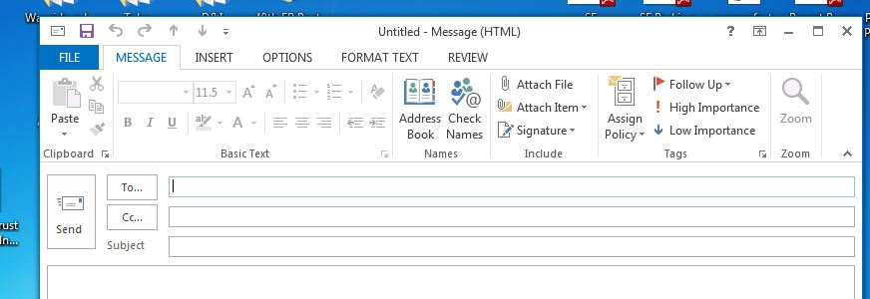
- Open your Wayside- Microsoft Outlook 2013 email
- In the top, left corner, click “New Email
- When the new email window appears, click “Signature” in the header.
- If you do not have a signature already set up, you will be prompted to do that first. However, click “Signature” to edit or create a new signature.
- After you set up your Signature according to Wayside communication protocol, be sure to highlight your pronouns and “INSERT” -> “HYPERLINK” -> inserting the following webpage in the “ADDRESS” box linking to this page: https://www.waysideyouth.org/aboutus/diversityinclusion/

